FOR IMMEDIATE RELEASE, Contact: Deryck Todd
BowieBall@gmail.com

BowieBallNYC.com
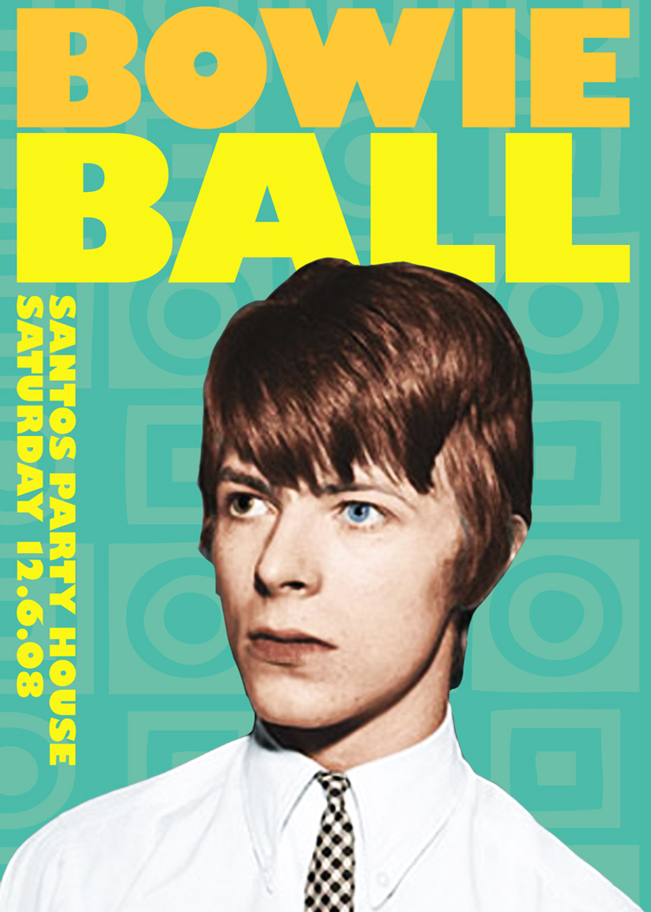

BOWIEBALL
YOUNG BOWIE DOES 2008
Saturday, December 6th, 2008
Location: Santos Party House, 100 Lafayette St.
10 pm-4am

Back by popular demand, nightlife impresario Deryck Todd presents the winter 2008 installment of BowieBall: celebrating the apex of electric excess— BowieBall pays homage to the definitive rock icon: David Bowie, in an anything-goes charity extravaganza bringing together the best in music, art, fashion, and entertainment.

The event is set at Andrew WK’s newbie hotspot Santos Party House, with best-selling subject of Confessions from the Velvet Ropes, notorious door persona Thomas Onorato, tapping in the in crowd. To rock who rolls in, New York’s hottest DJ’s Jake D (Minou/One Night Stand), Rok One (The Bangers), Lilly of the Valley, Irish import Bobby Analog and Michael T. (Motherfucker/Rated X) will spin exclusive Bowie smashups that’ll make the glitterati shimmer and shake. Hosts Patrick Duffy, TheFrisky.com’s Simcha, public relations savant Miss Riss, Justin Hyte, celebrity make up artist Jasen Kaplan, and L Magazine guru Zachary David Palmer will prime the colorful crowd for resident Village Voice photographer Miss Maro.
A live band will churn out star-studded Bowie covers from some of New York’s most infamous entertainers including Keanan Duffty (Slinky Vagabond) featuring original Bowie guitarist Earl Slick, downtown diva Michael Formika Jones, tribute band Ziggy Starlet & Miss Guy. To take you to suffragette city, choreographer Jonte, gender bending Pixie Harlots, burlesque beauty Dirty Martini & the fire-crotch King of boylesque Tigger will strut their stuff to classic Bowie tracks.

To rock out in true Bowie style, Frank Glover Productions will be supplying a fashion mannequin installation to be decked out like David by Fashion Institute of Technology, Celebutante’s Richie Rich, VH1 Glam God’s Indashio, Britain’s pink lady Zandra Rhodes, Keanan Duffty, menswear rogue Andrew Buckler, Don Patron, Stephen Burrows, fashion house Albright NYC, Vespa Brooklyn, underground couturier Garo Sparo and Ben Sherman.

In a room full of people who refuse to blend in, an attention-grabbing outfit could win a Ben Sherman gift certificate in the costume contest judged by Project Runway’s punk darling Stella B. Zotis. From striking go-go dancers, to glam make-up makeovers and lightening bolt cookies, there’s guaranteed to be enough dazzle and decadence to properly pay homage to the living rock n’ roll idol.

Notorious for turning out those that are wild enough to be in the downtown underground, BowieBall has been heralded as the “it affair” by Nylon Magazine and attendees like Mick Rock, Dita Von Teese and Patricia Arquette. Let your inner lightening bolt strike at BowieBall, the consummate nightlife event celebrating the stardustry and glamour of those basking in all of glitter’s golden years
BOWIEBALL
Date: Sat Dec 6th 2008 10pm–4am
Location: Santos Party House, 100 Lafayette St @ Walker. NYC
Dress Code: Warholian Superstar, Young American Heroes & Goblin Kings
Cost: $10 W/RSVP TO WWW.BOWIEBALLNYC.COM
$15 ADVANCED & GUARANTEED ENTRY WWW.TICKETWEB.COM
$20 DAY OF WITHOUT
Proceeds Donated to The Northern Westchester Shelter
WWW.SANTOSPARTYHOUSE.COM

