B O W I E B A L L
THE ULTIMATE GLAM ROCK REVOLUTION

CELEBRATING COLUMBUS DAY WEEKEND!

Sunday, October 10th, 2010
Santos Party House, 96 Lafayette St @ Walker
www.santospartyhouse.com
8 pm - 4 am

Back by popular demand, nightlife impresario Deryck Todd presents the Fall 2010 installment of BowieBall: celebrating the apex of electric excess - BowieBall pays homage to the definitive rock icon: David Bowie, in an anything-goes charity extravaganza bringing together the best in music, art, fashion, and entertainment.

Notorious door persona Thomas Onorato will tap in the in crowd at hot spot Santos Party House with a film showing of The Hunger for the early birds at 8 pm. Following to rock who rolls in, New York’s hottest DJ’s Michael T (Motherfucker), Jake B (Diesel), Rich King, June D (White Doves), Prince Terrence (Hussle Club) & Jess (Trash!) will spin exclusive Bowie smashups. Hosts Ellie Conant (Choice Cunts), TheFrisky.com’s Simcha, Zachary David Palmer & bombshell brunette Shien Lee (Dances of Vice) will shimmer in the glitteratti for resident Sirius Radio photographer Maro Hagopian and stilt walker Joshua D (House Of Yes).


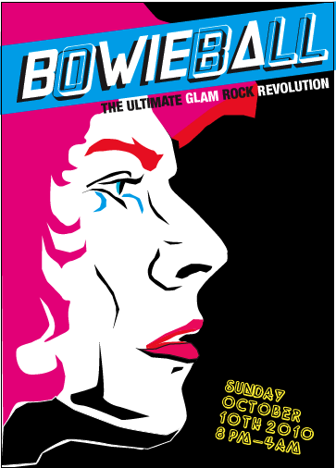

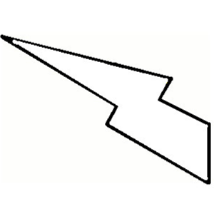
Backed by a live band churning out star-studded Bowie classics, performers are Brooklyn based Vimeonados CHERYL, the legendary Taylor Mac, Sacred Center Gospel Choir, bodacious chanteuse Bridget Everett, fiery ginger Reni Lane, The Mystery of Claywoman’s Michael Cavadias, Slingky Vagabond headliner Keanan Duffty, glamagod Michael T, downtown diva Lady Rizo, psychedelic dandy David Riley (Mirror Mirror), Carolyn Tauro & the infamous Militia. The gender bending dancers Daisy Spurs, T Pow (Wau Wau Sisters) and Vic Thrill, and very pregnant Little Brooklyn will strut their stuff to pure stardust.

Additionally, there will be hair overs by Bumble and bumble and make up make overs with gift bags giveaways galore. An attention-grabbing outfit could win a $200 Ben Sherman gift certificate and a special giveaway of Fred Schneider (B-52s) and his band The Superions "Destination...Christmas!" CD in the costume contest judged by a very special surprise guest!

Notorious for turning out those that are wild enough to be in the downtown underground, BowieBall is heralded as the “it affair” by Nylon Magazine and attendees like Mick Rock, Debbie Harry and Chloe Sevigny. Let your inner lightening bolt strike at BowieBall, the only exclusive New York nightlife event for covering yourself in glitter’s golden years.

DRESS CODE Space Age Jumpsuits, Vampire Hunger & Baby Blue Suits
$10: til 10 PM W/RSVP: BOWIEBALL@GMAIL.COM
$15: ADVANCED: WWW.BROWNPAPERTICKETS.COM
$20: DAY OF WITHOUT AFTER MIDNIGHT

Proceeds Donated to The Northern Westchester Shelter

